Postal Life Insurance

Department of Post

Software Requirements Specification (SRS)/ Functional Requirements Specification (FRS)
  - User Management

INTERNAL APPROVAL FORM

Project Name: User Management
Version: 1.0
Submitted on:
 | Name | Date
Approved By:
Reviewed By:
Prepared By:

VERSION CONTROL LOG
Version | Date | Prepared By | Remarks
1

Table of Contents

1. Executive Summary 4
2. Project Scope 4
3. Business Requirements 4
4. Functional Requirements Specification 5
4.1 User Management 5
4.2 Role Management 6
4.3 Queue Management 6
4.4 Group Management 6
4.5 Audit & Logging 6
5. Test Cases 7
6. Appendices 8

1. Executive Summary
This document defines the software and functional requirements for the User Management Module of the Insurance Management System (IMS) for India Post PLI. The purpose of this module is to enable administrative control over users, their roles, access permissions, work queues, and groups, ensuring proper segregation of duties, operational efficiency, and compliance with regulatory and internal security policies.

2. Project Scope
The User Management module will:
- Manage creation, modification, deactivation, and reactivation of system users.
- Define and assign roles, queues, and groups for controlled access and workflow management.
- Ensure secure authentication, authorization, and auditability.
- Integrate with other IMS components (Policy Administration, Claims, Premium Collection, etc.) for role-based data access.

3. Business Requirements
Requirement ID | Business Requirement | Requirements Description
FS_UM_001 | Centralized User Administration | System shall provide a centralized interface to manage all IMS users across India Post PLI.
FS_UM_002 | Role-Based Access Control (RBAC) | Access to modules, functions, and data shall be controlled via predefined roles.
FS_UM_003 | Queue Management | Work allocation (e.g., policy issuance, claims, underwriting) shall be handled via user queues.
FS_UM_004 | Group Management | Logical grouping of users (e.g., under a branch, region, or function) for task assignment and reporting.
FS_UM_005 | Audit Trail | All user management activities (create, update, deactivate, role change) shall be logged with timestamp and actor details.
FS_UM_006 | Authentication & Security | Secure login, password policies, OTP/2FA (as per India Post IT policy).
FS_UM_007 | User Lifecycle | Support user creation, activation, suspension, termination, and reactivation.
FS_UM_008 | Delegation & Substitution | Allow temporary assignment of queues or roles to another user during absence.
FS_UM_009 | Approval Workflow | Changes to roles, queues, or group assignment may require approval by authorized supervisor.
FS_UM_010 | Integration | Should integrate with centralized India Post employee directory or HRMS for validation of user identity.
FS_UM_011 | Reporting | Generate reports (active/inactive users, roles, login activity, audit logs).

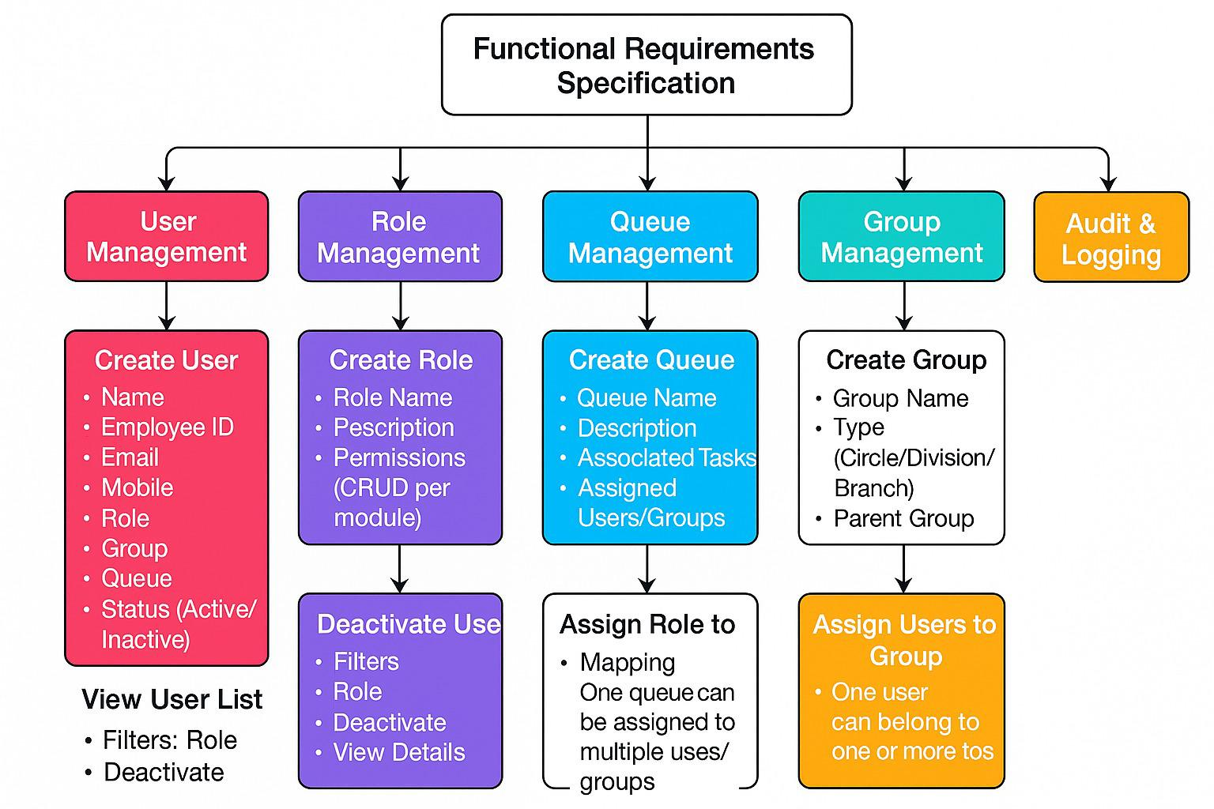

4. Functional Requirements Specification

4.1 User Management
1. Create User
- Fields: Name, Employee ID, Email, Mobile, Role, Group, Queue, Status (Active/Inactive)
- Validations: Unique Employee ID, Valid Email Format
2. Edit User
- Editable Fields: Role, Group, Queue, Status
3. Deactivate User
- Action: Mark user as inactive without deleting data
4. View User List
- Filters: Role, Group, Status
- Actions: Edit, Deactivate, View Details

4.2 Role Management
1. Create Role
- Fields: Role Name, Description, Permissions (CRUD per module)
2. Edit Role
- Editable Fields: Description, Permissions
3. Assign Role to User
- Mapping: One user can have multiple roles (if allowed by policy)

4.3 Queue Management
Define queues for task allocation (policy issuance, underwriting, claims, etc.). Assign users or groups to queues. Manage queue ownership and load distribution.
1. Create Queue
- Fields: Queue Name, Description, Associated Tasks, Assigned Users/Groups
2. Assign Queue to User/Group
- Mapping: One queue can be assigned to multiple users/groups

4.4 Group Management
Create and manage user groups (branch, regional, functional). Assign users and roles to groups. Define reporting structure.
1. Create Group
- Fields: Group Name, Type (Circle/Division/Branch), Parent Group
2. Assign Users to Group
- Mapping: One user can belong to one or more groups

4.5 Audit & Logging
Every change to user, role, queue, or group shall record:
- Action Type (Create/Edit/Delete/Assign)
- User ID performing the action
- Timestamp
- Old and New values
- IP Address / System Source

5. Test Cases
TC ID | Requirement ID | Test Case | Description | Expected Result | Type
TC_UM_001 | FS_UM_001 | Centralized User View | Verify centralized interface displays all IMS users. | All users across branches are visible in one interface. | Positive
TC_UM_002 | FS_UM_007 | Create User | Validate successful creation of a new user with valid details. | User is created and appears in user list. | Positive
TC_UM_003 | FS_UM_002 | Assign Role | Verify assigning predefined role to a user. | Role is assigned; user gets correct permissions. | Positive
TC_UM_004 | FS_UM_003 | Queue Assignment | Validate adding user to a work queue (e.g., claims). | User is added to queue and tasks appear in their dashboard. | Positive
TC_UM_005 | FS_UM_004 | Group Assignment | Verify grouping users under a branch or region. | Group is created and users are linked correctly. | Positive
TC_UM_006 | FS_UM_005 | Audit Trail Logging | Check audit log for user creation and updates. | Audit log shows correct timestamp, actor, and action. | Positive
TC_UM_007 | FS_UM_006 | Secure Login | Validate login with correct credentials and OTP/2FA. | User logs in successfully with secure authentication. | Positive
TC_UM_008 | FS_UM_006 | Password Policy | Verify password meets complexity rules. | Password accepted only if it meets policy requirements. | Positive
TC_UM_009 | FS_UM_007 | User Lifecycle | Test activation, suspension, termination, and reactivation. | Status changes correctly and reflected in system. | Positive
TC_UM_010 | FS_UM_008 | Delegation | Validate temporary delegation of queues to another user. | Delegation works for specified period and reverts automatically. | Positive
TC_UM_011 | FS_UM_009 | Approval Workflow | Verify role change requires supervisor approval. | Change is pending until approved; audit logs updated. | Positive
TC_UM_012 | FS_UM_010 | HRMS Integration | Validate user identity against HRMS directory. | User details match HRMS; creation allowed. | Positive
TC_UM_013 | FS_UM_011 | Reporting | Generate report of active/inactive users and login activity. | Report generated accurately in required format. | Positive
TC_UM_014 | FS_UM_007 | Duplicate User Creation | Attempt to create user with existing ID. | System rejects with “Duplicate User ID” error. | Negative
TC_UM_015 | FS_UM_002 | Invalid Role Assignment | Assign non-existent role to user. | System shows error “Invalid Role”. | Negative
TC_UM_016 | FS_UM_001 | Unauthorized Access | User without admin rights tries to create another user. | Access denied with proper error message. | Negative
TC_UM_017 | FS_UM_006 | Weak Password | Enter password not meeting complexity rules. | System rejects password with policy message. | Negative
TC_UM_018 | FS_UM_006 | Invalid OTP | Enter incorrect OTP during login. | Login fails with “Invalid OTP” error. | Negative
TC_UM_019 | FS_UM_008 | Expired Delegation | Try accessing delegated queue after expiry. | Access denied; delegation period expired. | Negative
TC_UM_020 | FS_UM_009 | Missing Approval | Attempt role change without supervisor approval. | Role Change should not be allowed. | Negative

6. Appendices
The Following Documents attached below can be used.

